Eddie Sanchez

Date: March 4, 2019

GSP 216: Remote Sensing

# **Analyzing Digital Image Resolutions and Creating a Region Of Interest Map of the Soberanes Fire (2016)**

This lab is all about understanding and learning how to analyze different digital image resolutions. To define what is digital image resolution is we must first define what is a digital image. A digital image is a single-band image composed of discrete picture elements or also known as pixels. Digital image resolution is a broad term because it has several characteristics such as spatial, spectral, radiometric, and temporal resolution for digital raster images. In remote sensing, most of all the images used are in a raster digital format. According to the Humboldt State Geospatial Online Website, describes the characteristic found in raster image resolutions. First, the spatial resolution it's the resolution that is the most common when downloading LandSat 8 images, it's a 30 meter data because most of the bands capture pixels that are 30 meters by 30 meters. Spectral resolution is the range of spectrum that captures the number of bands. Temporal resolution is the return or time of a photo, in other words, the time it takes to receive a photo from a remote sensing device. Radiometric resolution is described as the number of bits for each individual band for the images, meaning that depending on the number of bands will determine the number of bits. For this lab, I look at four digital images with different resolution types from different remote sensing devices (satellite and aerial devices).

In this lab, I analyze how each image compares in spatial, spectral, radiometric, and temporal resolutions. The Images used in this lab came from various sensors. I used images from Landsat 8, MODIS, NAIP, and RapidEye in ENVI 64-Bit to analyze the different resolution characteristics (All images were projected using WGS_1984 UTM Z 10N). These images are from the Soberanes 2016, fire region. The learning objectives of this lab are to learn why these resolutions types are different. They are different for several reasons beyond the resolution type, for example, each image for the lab could be used for a different application. In this lab I also learned about the ENVI software tool functions used to digitize the perimeter of the Soberanes Fire (2016). Using the LandSat 8 image, I made a false color composite image. When making a false-color composite image, I was able to easily identify the fire’s boundary and create a Region Of Interest (ROI) map in Esri’s ArcMap software. The false color composite image and the tools in ENVI help calculate the total area of fire burn in Soberanes, Ca.

**Methods**

**These Lab Methods are split into two parts:**

***(1)* Analyzing the images *& (2)* Creating Region of Interest (ROI) Map**

*(1)* The first step in analyzing any type of satellite image is to create the original, and final folder on the desktop, after creating the folders the next step is to download the data. I acquired the data from the google drive shared folder. The LandSat image used for this analysis is titled “Landsat.dat”, “Modis.dat”, “NAIP.dat”, and “RapidEye.dat” they are raster files. The image is located in the shared google drive folder, under GSP 216, Lab 5. Once it is download unzip it and saved it into the original folder the next step is to open the image using the ENVI-64-Bit software. For the next steps all layers in the default setting. The next step in analyzing the images is to use ENVI library tools, to understand how to layer each photo. By using the Blend, Flicker, Portal, and Swipe view tools allow the viewer to easily compare two image layers. The Blend tool is used for slowing animate between the two layers. The portal tool can be used for overlaying photos, showing what the layer looks underneath. The portal tool is used to see what the resolution looks like for the same area. The Flicker tool can be used to create an animation that swipes the images (on and off). The Swipe tool can be used to create an animation that switches the images from right to left. The next step would be displaying all images simultaneously (under the view tab and merge views), and browsing around the surfaces, zooming in and out comparing the images. After taking some time to analyze how these resolution types are different, an easy way of taking notes is to make a table. In the table, I wrote the columns as the sources of each image (MODIS, LandSat 8, RapidEye, NAIP), and the rows are the resolution types (spatial, spectral, radiometric, and temporal). All of this information is crucial in having to analyze each individual image and how they differ from one another. Next, I used some of the metadata of the images, found in the original final folder, to write down the Spatial, and Spectral resolution, and also the Date Acquired of each image. I needed to additional research for the Radiometric and Temporal resolution because It was not included in the metadata. Once all the information is documented, it can be used to describe how each photo is different, and discuss the advantages and disadvantages of each resolution.

**Table 1. Table showing the Digital Images Sources (MODIS, LandSat8, Rapideye, and NAIP) and Resolution Types (Spatial, Spectral,Radiometric, Temporal Resolution)**

|  |  |  |  |  |
| --- | --- | --- | --- | --- |
|  | MODIS (GOV/Reprojected)  Satellite | Landsat 8  Satellite | Rapideye  Satellite | NAIP (GOV/Reprojected)  -Airplane |
| Spatial Resolution | Pixel size X: 500m  Pixel size Y:  500m | Pixel size X: 30m  Pixel size Y:  30m  bands 5 is 15m  Bands 7 & 8 are 100 m <https://landsat.gsfc.nasa.gov/landsat-8/landsat-8-bands/> | Pixel size X: 5m  Pixel size Y: 5m | Pixel size X: 0.6m  Pixel size Y:  0.6m |
| Spectral Resolution | Number of Bands: 36 spectral bands  Wavelength or Range: 0.4 µm to 14.4 µm. | Number of Bands: 7 bands Including the visible spectrum and Infrared  Wavelength or Range: 0.4 µm to 12.5 µm | Number of bands: 5 Bands    Wavelength or Range: 0.4 µm to 0.885 µm | Number of bands: 4 bands  Including the Near infrared  Wavelength or Range: 0.4 µm to 0.885 µm |
| Radiometric Resolution  (Research online=bits) | 12 bit | 16 bit | 12 bit | 32 bit |
| Temporal Resolution  (Research Online=return or revisit time) | 1-2 Days | 16 Days | 5.5 Days | NAIP CCMs are due at APFO 30 days after flying, and are made available within 24 hours of arrival at APFO  <https://www.fsa.usda.gov/programs-and-services/aerial-photography/imagery-programs/naip-imagery/index> |
| Date Acquired  (Year-Month- Day) | 2016-08-08 | 2016-08-07 | 2016-07-23 | 2016-07-23 |

*(2)* The first step in creating a ROI map is to re-open the Landsat.dat image is to make a false-color composite image to filter out the fire smoke, and make the fire burn areas more easily detectable. To make the false color composite image, I needed to change the bands in the select the near infrared box. The false color composite I used was switching the “SWIR 2” infrared box to the color red and switching the “SWIR 1” infrared box to the color blue and green shown in (Figure 1). The results of this false-color composite are alternating the vegetation type (Figure 2). Once the false color composite image is made, In ENVI one can start to digitize the perimeter of the fire using the Region Of Interest Tool. This tool is like the draw tool in ArcMap, however, this tool has a window that can tell one about the total area of the surface that was digitized. Once digitizing is completed, I saved, and exported the file as a shapefile format, and uploaded it into ArcMap to add the cartographic features.

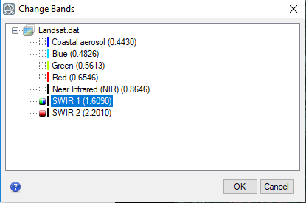

**Figure 1. Shows the false color composite I used for the LandSat.dat Image, SWIR 2” infrared box to the color red, and switching the “SWIR 1” infrared box to the color blue and green.**

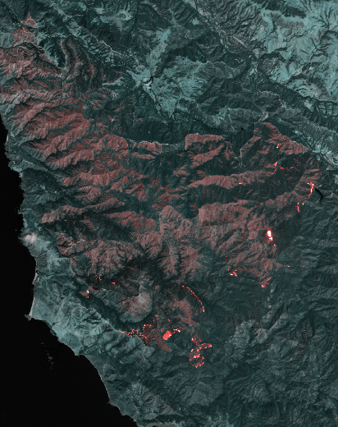

**Figure 2. Shows the results of switching the bands of LandSat.dat image of the Soberanes 2016 Fire. In the image Fire is red, Healthy Vegetation is Greyish Blue.**

**Results and Discussion**

For this report, I took a look at four different images of the Soberanes 2016 fire, South of Monterey County located in Central California. All of these images were taken in the same area, however, they showed a variety of different spatial, spectral, radiometric, and temporal resolutions. The table created in this lab helped me analyze which image has the highest and lowest spatial resolution. From my own analysis, I can state that NAIP.dat has the highest resolution. The NAIP image was cropped only to fit the Fire Boundary, this was an indication that It must be a high resolution as well. In this image, I can easily identify forest cover, if this image showed more of the land cover could clearly see all types of features in a very high resolution. If this image was not cropped I can predict I would be able to see cars, roads, buildings, and land development areas in greater detail and the file size would be very big.

The image with the lowest resolution from this lab is the MODIS.dat image. When zooming in this photo, it becomes more pixel and difficult to identify features. Even though the MODIS image has the fastest temporal resolution, and the largest spectral resolution it doesn’t mean it has the best resolution for this application. One cannot identify any features beyond a certain threshold when zooming into the image. The LandSat 8 and RapidEye images had similar resolutions because one could easily identify vegetation, land development, roads, and able to view the smoke from the fire. RapidEye had a slightly better spatial resolution overall, however, it looked very similar and would be difficult to distinguish both in true color from.

From my analysis, I can identify what are some of the advantages and disadvantages of spectral and spatial resolution. The advantages of having a spatial resolution are that it determines the sharpness of an image. Images that have a lower spatial resolution like in the RapidEye.dat (5X5 meters) image, was able to zoom in without being too pixelated too quickly. The disadvantages are that when one does zoom in too quickly it becomes pixelated and hard to make out some features. Some advantages of high spectral resolutions are able to capture more features on the electromagnetic spectrum. For example in this lab, we analyze the MODIS.dat image as the image with the lowest resolution because it became pixelated too quickly, however, when you change the color bands on this image one is able to capture more features that are not visible to the naked eye. The only drawback to high spectral resolution is that the file size can get big and diffcult to upload/download files. In this lab, I changed the color bands of the MODIS.dat image and was able to filter out the fire smoke and see the burn area in greater detail. The advantages of spectral resolution is that it spots changes over time quickly. When analyzing the image with the faster return time, it's the NAIP.dat image. This image has the quickest turn time, however, the opportunity cost is that again the file size for high-resolution photos can get big. The image with the highest spatial resolution was also had the highest radiometric resolution can make out eveures. However, the drawback to having high radiometric resolution resolution is that our visible eyesight can only see 8-bit resolution.

In the lab, I changed the color bands of the LandSat 8.dat image. I decided to change the color bands of this image because it had one of the best Spectral Resolution out the four images to make a false-color composite image to make the fire more visible. By changing the color bands I was able to digitize the perimeter of the fire boundary and calculated the area burned, using the ENVI software tools. I calculated that the estimated area of the burn was 58,764.94 Acres shown in (Figure 3.). This is the knowledge that is useful to the Forest Service, Wildfire Services, and Wildlife Fish and Game Services. This Landsat image is good for this type of application because it has a wide range of spectral bands able to capture features on the electromagnetic spectrum, a good radiometric resolution, and a decent temporal resolution to do a fire analysis. All images have a different specialized application, for instance, MODIS image can be used for easily identifying algae in a lake. The NAIP image can be used for urban development and development with water sources. Rapideye images can be with a combination of LIDAR to measure the Ice Glaciers melting in the Arctic. And lastly, Landsat is a good all-around image that can be used for gradual changes over periods of time and identifying environmental destruction.

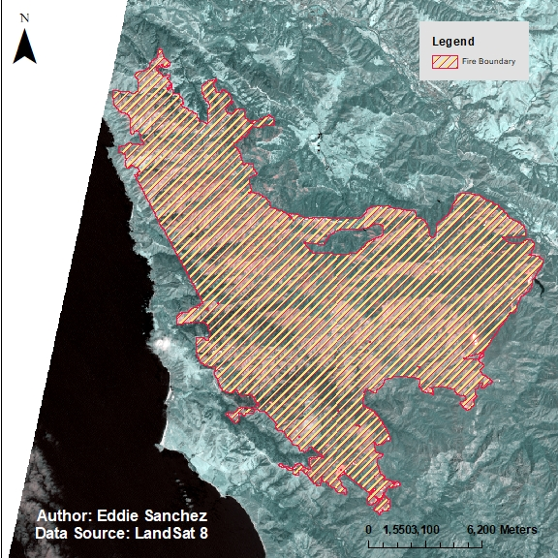

**Figure 3. Shows Fire Boundary west of Hyampom, CA. The area of the Fire Boundary is: 58,764.94 Acres.**

# **Acknowledgements**

Humboldt University GSP 216 Lab

Google Share Drive (Obtain Raster Images)

LandSat 8

RapidEye

NAIP

MODIS

Humboldt State Geospatial Online Website